User Guide – How to Change a Style in MS Word

Contents
Definition of Style in MS Word 2
Procedure to change Style 2
Purpose 2
Flowchart 3
Screen capture 4
Version History 5

Definition of Style in MS Word

Style are pre-defined text format, which are used to distinguish the different parts of a document.

Procedure to change Style

To change the Style in MSWord the user must to simply select the text that he wants to change and select the style to be applied.

Purpose

This functionality in MS Word is very useful for BA, as it allows them to create custom Styles for the many document templates they must fill up, making the process to write professional documents more easy and quicker.

Flowchart

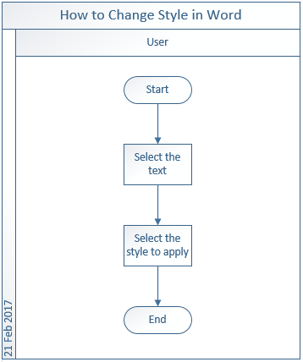

Screen capture

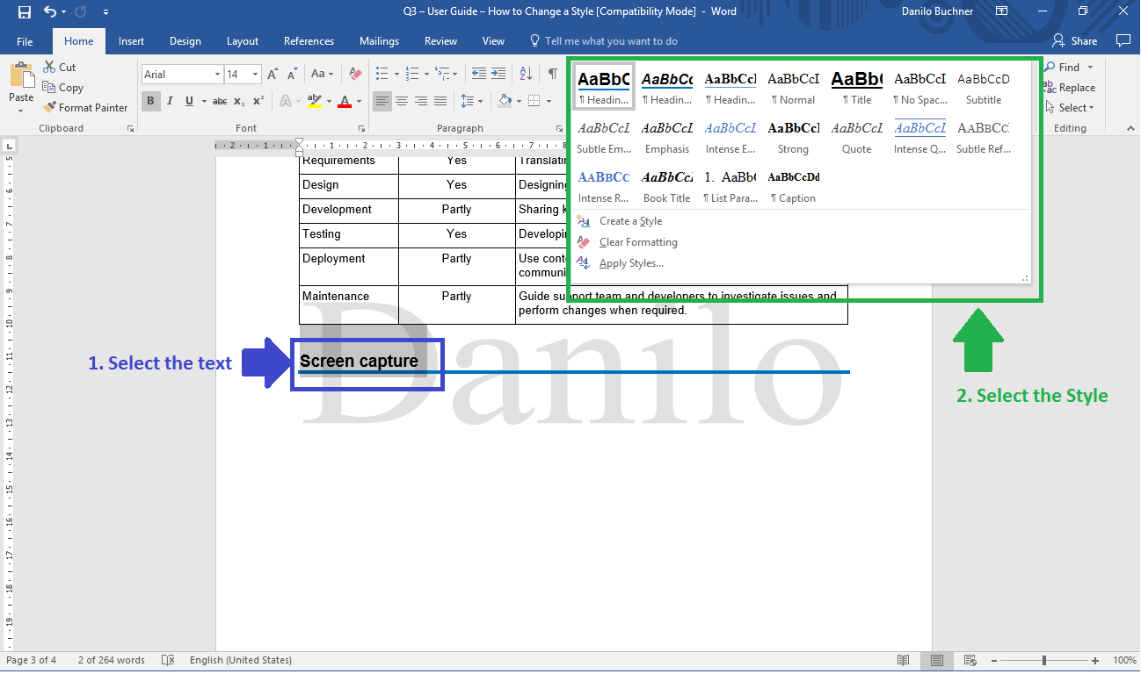

Version History

Version | Date | Status | Description | Author
01 | 21 Feb 2017 | Final | Creation of the user guide on how to change style. | Danilo

